4a, b, c. Refer Notes

http://www.cs.cmu.edu/~10701/slides/10-701_Fall_2017_Recitation_2.pdf

5.

a. <https://www.youtube.com/watch?v=PiXu8_4X5dE>

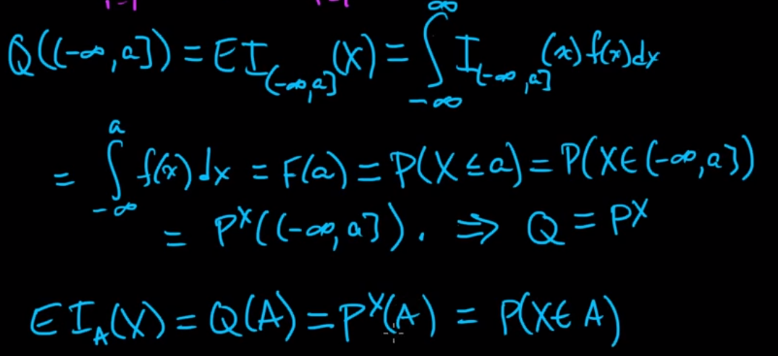

b. https://www.youtube.com/watch?v=tFF2HXHNwcY

c.

the size grows exponentially with the dimension d.

2^784(number of bins^ dimensions)

<https://www.easycalculation.com/power-of-numbers.php>

d.

number of training points/region=k

e.

<https://people.eecs.berkeley.edu/~jfc/cs174/lecs/lec5/lec5.pdf>

<http://pages.cs.wisc.edu/~shuchi/courses/787-F09/scribe-notes/lec7.pdf>

6.a

Merge these 2 links below

<https://beginningwithml.wordpress.com/2018/09/18/7-gaussian-discriminant-analysis/>

<https://towardsdatascience.com/gaussian-discriminant-analysis-an-example-of-generative-learning-algorithms-2e336ba7aa5c>

Additional Ref <https://funglee.github.io/ml/slides/Lecture5-NaiveBayes-Notes.pdf>

6. b.

Note that the two Gaussians have contours that are the same shape and orientation, since they share a covariance matrix Σ, but they have different means µ0 and µ1.

<https://svivek.com/teaching/lectures/slides/naive-bayes/naive-bayes-linear.pdf>